

**RAFFLES INSTITUTION**

**YEAR 3 COMPUTER ELECTIVE PROGRAMME**

**PROJECT PROPOSAL**

**Project Team:**

Arnold Tan An 3C

Ooi Wei Ming Nelson 3B

**Project Name:** AyeMerp

**Statement of the Problem:**

Humans are social creatures. We often have to socially interact with others. During these social interactions, we sometimes find ourselves having certain feelings/intentions towards others.

However, we may not have the courage to confess our feelings/intentions towards that person as we may fear outright rejection, feeling awkward and ruining the relationship with that person. For example, person A may have a secret crush on person B but he is unsure whether person B has a crush on him too. Person A does not want to risk ruining their friendship and chooses not to confess to person B.

This fear of uncertainty can lead to many people losing out on opportunities to further develop their relationship, as in the case of person A, if person B actually has a crush on person A but person A chooses not to confess out of fear, then both person A and B will lose out on a very good opportunity to develop their relationship.

**Objectives:**

The goal of AyeMerp is to eliminate people’s fear of outright rejection, feeling awkward and ruining the relationship with the other person when trying to express their feelings/intentions towards the other person.

AyeMerp solves this problem and achieves our goal by acting as a middleman between users. AyeMerp will allow users to express their feelings/intentions towards other users in their relationships without informing the other users. The feelings/intentions a user express to another user would be stored and remained a secret within AyeMerp, only when the other user reciprocates with the same feelings/intentions, both parties would be informed of their common feelings/intentions.

**Technical Approach:**

Our web-based application would be built using Django as a backend. For user and session authentication, we are using Django’s built-in authentication system. For storing of all user data, we are using the default database configured by Django, SQLite. For our user interfaces, we are rendering our webpages with Django’s built-in templating engine and styling our webpages with Bootstrap, a CSS framework. For real-time updates of user’s feelings/intentions, we will use gevent-socketio which requires gevent and gevent-websocket, this is similar to the API of socket.io built for Node.JS.

**External Scan:**

After conducting a search on similar applications, we found only one application that is most relevant to our idea.

The mobile app called Down, available on Google Play Store (<https://play.google.com/store/apps/details?id=com.bang.bangwithfriends>), has a similar concept of eliminating awkwardness where user would not know another user’s intentions until both of them have similar intentions.

However, Down focuses only on dating and hookups whereas AyeMerp do not intend to limit feelings/intentions to only dating and hookups. AyeMerp would support different kinds of feelings/intentions in various forms of relationships, such as parent-child relationships, student-teacher relationships, co-worker relationships, etc.

In terms of user-friendliness, Down has received a rating of 3.4 stars on Google Play Store (as of 1 September 2015, 2315h). Although the comments may be biased, a quick scan of feedback on the app’s page in Google Play Store shows largely negative comments, such as complains of poor user experience. Hence AyeMerp can fill in these gaps in terms of our user experience and our holistic application of this concept, which can potentially attract a wider range of users.

**Use Case Scenarios:**

1. **Users in platonic relationships**

One possible use case of AyeMerp for users in platonic relationships is to express their crush on the other user in the relationship. If both users in a platonic relationship have a crush on each other, then they can take their relationship to the next level.

1. **Users in romantic/intimate relationships**

One possible use case of AyeMerp for users in romantic/intimate relationships is to express their sexual desires with the other user in the relationship. This is particularly helpful as in some teenage intimate relationships, the parties involved in the relationship may be shy and not as open to each other as compared to a more mature relationship such as in a marriage. With AyeMerp, both users in a romantic/intimate relationship can know the sexual desires they have in common without much embarrassment or awkwardness.

1. **Users in co-worker relationships**

One possible use case of AyeMerp for users in co-worker relationships is to express their dislike for their employer. This is particularly useful as both co-workers in a relationship can share similar negative feelings towards their employer and if they do not have similar feelings towards their employer, they will not find out about each other’s feelings towards their employer, thereby preventing potential unhealthy co-worker relationships at work.

**Feature Listing:**

* **User Accounts/Profile**

Users can create user accounts that represent themselves by having a profile picture and adding of personal details such as name, age, nationality, etc..

* **Different types of relationship between users**

AyeMerp comes with built-in different types of relationship, for e.g., teacher-student relationships, co-workers relationships, parent-child relationships, platonic relationships, romantic/intimate relationships, marriage, etc.. Users are allowed to have multiple different types of relationships with a single user.

* **Expression of relationship-specific feelings/intentions**

AyeMerp comes with built-in relationship-specific feelings/intentions that users can choose to express to another user they are currently in a relationship with. Their feelings/intentions would be kept confidential as long as the other user does not reciprocate with the same feelings/intentions.

* **Notification of common feelings/intentions**

Once both users in a relationship expresses common feelings/intentions towards each other, both parties would be informed.

**Design Mockups:**

The raw images of the sketches below are found in the folder named “Design Mockups”

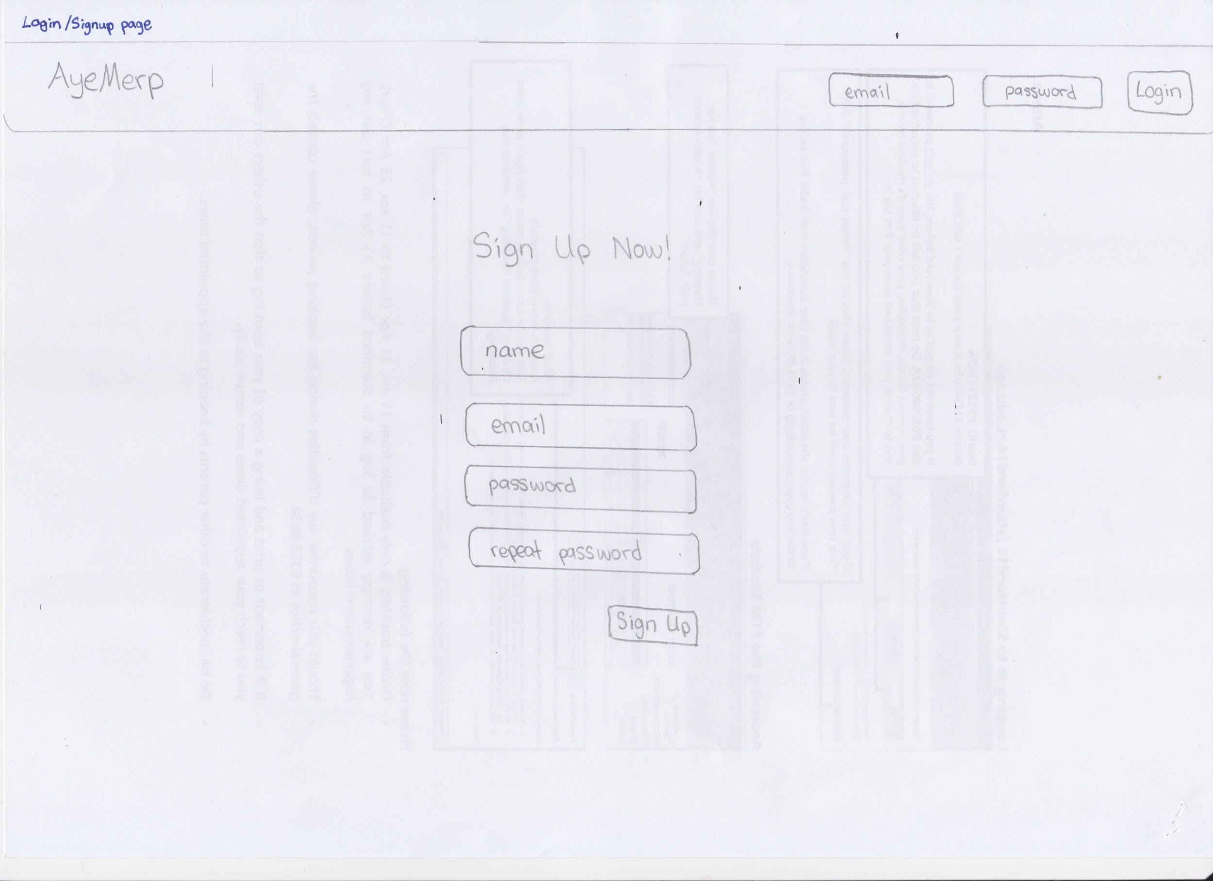

(image name: landing.jpeg)

This is a sketch of our landing page that allows users to sign up for an account and login.

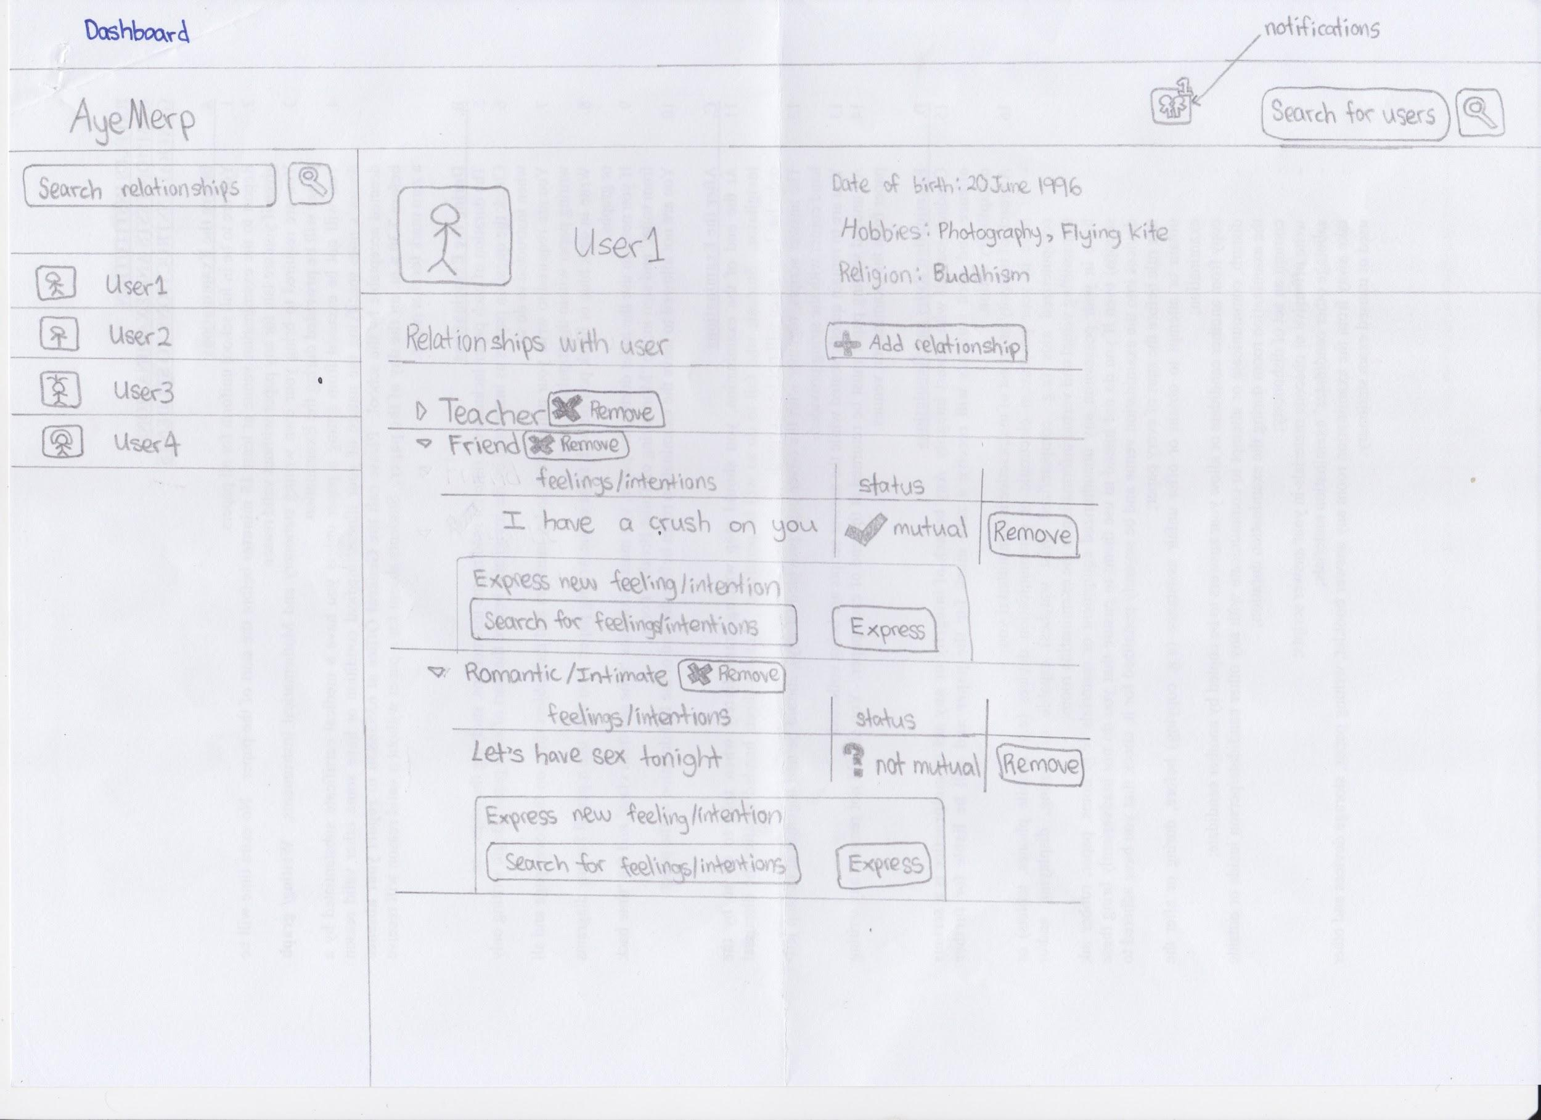

(image name: dashboard.jpeg)

This is a sketch of the user dashboard, the page that user would be redirected to upon login. The dashboard has a search function to search for other users and a notification icon to inform of new common feelings/intentions in the bar at the top of the webpage. Users can search for users that they currently have relationships with in the left sidebar. The main content of the dashboard displays a specific user’s profile and the relationships that exists between that user and the logged-in user. The logged-in user can add/remove relationships, add/remove feelings/intentions and track whether their feelings/intentions have been reciprocated.

**Project Fact Sheet**

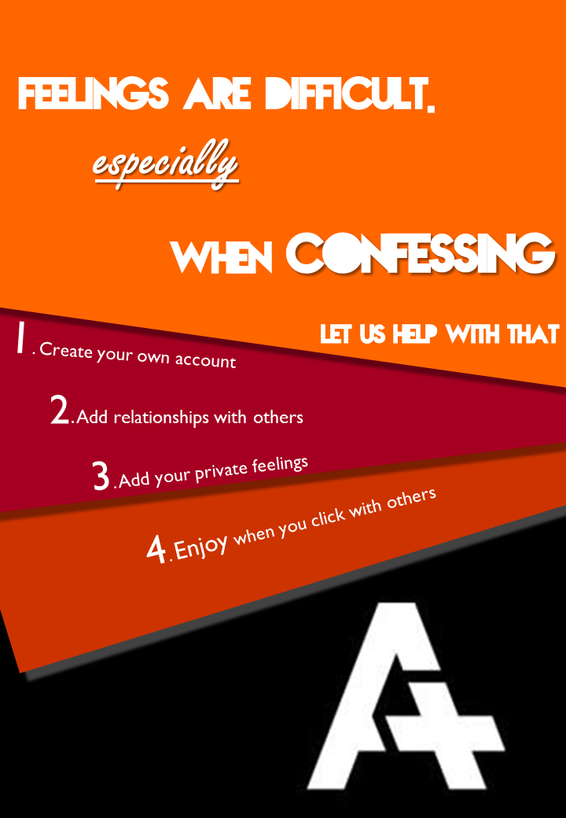

**Measuring success:**

We define this project as a success if we can implement all features of AyeMerp and not fail to implement certain features due to technical difficulties. For this project to be successful, AyeMerp must also fulfil the objectives of the project by having users who can eliminate their fear of outright rejection, feeling awkward and ruining the relationship with the other person, through the use of AyeMerp. However, in the event that our project does not progress beyond CEP lessons, our project can still be considered a success if we receive affirmation from our CEP teacher and peers that AyeMerp can potentially fulfil the objectives of the project.